
1
Project Report

Year 2026-27

Bachelor of Technology

In

Information Technology

Department of Information Technology

On
Submitted by

3
rd Year (6th Sem) IT

Subject: Internet of Things

Under the Guidance of

A Mini Project Synopsis submitted inpartial fulfillment of the requirements for

the award ofthe degree of

Solar Tracker System with LDR Sensor

Prof. Jeevan Mangrulkar

Mayur Sawarbandhe [51IT]

JD College of Engineering and Management,Nagpur-441501

(
An Autonomous Institute,with NAAC“A” Grade
)
Affiliated to DBATU,RTMNU &MSBTE Mumbai.


CERTIFICATE

Subject Incharge

IT Dept.
HOD IT Dept.
JDCOEM, Nagpur

This is to certify that the student listed below has successfully completed the Module Making Activity on the topic “Solar Tracker System with LDR Sensor” as a part of the academic coursework for the subject Internet of Things in the 6th Semester of the Bachelor of Engineering in Information Technology under the Faculty of Science and Technology at Dr. Babasaheb Ambedkar Technological University, Lonere.
The module has been designed, developed, and implemented by the student as a part of the practical learning process in the Internet of Things domain. The project focuses on the development of an automated solar tracking system using LDR sensors to detect the intensity of sunlight and adjust the position of the solar panel accordingly for maximum energy efficiency.
This work has been carried out under proper guidance and supervision, and the module submitted by the student is a genuine and original piece of work. To the best of our knowledge, this project has not been submitted previously for the award of any degree, diploma, or any other academic recognition in this or any other university or institution.
The successful completion of this activity reflects the student’s practical understanding of IoT concepts, embedded systems, sensor integration, and real-time implementation. It also demonstrates their ability to apply theoretical knowledge into practical applications through innovation, problem-solving, and hands-on experimentation.

Prof. Jeevan Mangrulkar
Dr. Moiz Baig
Student Details:

Mayur Sawarbandhe[51IT]

•


ABSTRACT

Solar energy is one of the most important and widely used renewable energy sources for electricity generation. However, the efficiency of a conventional solar panel is often reduced because the panel remains fixed in one position and cannot continuously face the sun throughout the day. To overcome this limitation, a Solar Tracker System with LDR Sensor is developed to automatically track the direction of maximum sunlight.
In this system, LDR (Light Dependent Resistor) sensors are used to detect the intensity of sunlight from different directions. Based on the variation in light intensity, the system automatically adjusts the position of the solar panel so that it remains aligned with the sun. This mechanism helps in capturing maximum solar energy and improves the overall efficiency of the solar panel.
The project demonstrates the practical application of sensors, automation, and renewable energy technologies. It also highlights how smart systems can be used to optimize energy utilization and support sustainable energy solutions.

INTRODUCTION

The solar tracking system with an LDR sensor is an innovative project designed to enhance the efficiency of solar energy collection. The system's main purpose is to automatically adjust the angle of a solar panel to follow the sun's movement throughout the day, ensuring it always receives the maximum amount of direct sunlight. The core of the system is an Arduino UNO microcontroller, which processes data from two LDR sensors strategically placed to detect light intensity. Based on the difference in light readings between the two sensors, the Arduino calculates the direction the solar panel needs to move. It then commands an SG90 mini servo motor to rotate the panel to the optimal position. This automated process addresses the inherent inefficiency of fixed solar panels, which lose a significant portion of their potential energy output as the sun's angle changes. By continuously re-orienting itself, this system provides a practical and effective solution to maximize solar power generation, aiming for up to a 30% increase in energy yield compared to a stationary panel. The project utilizes a single-axis tracking design, focusing specifically on following the sun's path from east to west. Crucially, the system is designed to be self-sufficient; it includes a battery charging module and a step-up booster that allows the system to be powered by the very solar energy it collects, enhancing its utility for remote or off-grid applications. The project's simple yet effective design demonstrates a key principle in renewable energy technology: optimizing energy capture to improve overall performance, all while utilizing low- cost, readily available components.

PROBLEM STATEMENT
Fixed-position solar panels suffer from a significant drawback: they are only capable of producing their maximum power output for a very limited time during the day. As the sun moves across the sky, the angle at which its rays strike the stationary panel changes continuously. This change in the angle of incidence results in a sharp decrease in the amount of solar energy absorbed, leading to a substantial reduction in overall efficiency and energy generation, especially during the morning and afternoon hours. The problem is to design and implement a cost-effective and automated system that can continuously adjust the orientation of a solar panel to maintain a perpendicular angle to the sun's rays, thereby maximizing its power output and improving the efficiency of solar energy collection. This energy loss undermines the potential of solar technology, making it less productive and less economically viable than it could be. Therefore, the problem is to design and implement a costeffective and automated system that can continuously adjust the orientation of a single-axis solar panel to maintain a perpendicular angle to the sun's rays. The successful implementation of such a system is necessary to maximize its power output and significantly improve the overall efficiency and reliability of solar energy collection.

3
. OBJECTIVES

• Automatic Sunlight Detection – To detect the direction of maximum sunlight using LDR (Light Dependent Resistor) sensors.
• Solar Panel Efficiency Improvement – To increase the efficiency of the solar panel by ensuring it always faces the direction of maximum sunlight.
• Automatic Solar Tracking – To develop a mechanism that automatically rotates the solar panel according to the intensity of sunlight.
• Sensor-Based Control System – To use LDR sensors and control systems to monitor light intensity and control the movement of the solar panel.
• Renewable Energy Utilization – To promote efficient use of renewable energy by maximizing solar energy absorption.
• Cost-Effective System Development – To design a simple and affordable solar tracking system using easily available electronic components.
• IoT Concept Implementation – To demonstrate the practical implementation of Internet of Things concepts in renewable energy systems.
• Sustainable Energy Solution – To encourage the use of smart and eco-friendly technologies for sustainable energy generation.



Software Components:

4
. HARDWARE AND SOFTWARE USE
•
Hardware Components:

1)

2)
3)

1)

2)

3)

light.

Arduino UNO
:
This is the brain of the system, a microcontroller board that reads data
from the LDRs and controls the servo motor.

Solar Plate
The primary energy source that converts sunlight into electrical energy.
:

LDR Sensor
The light sensors that change their resistance based on the intensity of
:

4)

SG90 Mini Servo Motor
:
A small motor used to precisely control the angle of the solar

panel.

5)

Resistor 100ohm
:
Used to create a voltage divider with the LDRs, allowing the

Arduino to measure light intensity.

6)

Battery Charging Module
:
Manages the power flow, ensuring the battery is charged

safely by the solar plate and that the system gets a stable power supply.

7)

Cell Holder
:
Holds the batteries that power the system.

8)

Step-up Booster
:
Increases the low voltage from the battery to a higher voltage

required to power the Arduino and servo motor.

9)

On/Off Switch
:
Provides a way to manually control the system's power.

10)
Arduino Cable
:
Used to upload the program code to the Arduino UNO.

11)

Connecting Wires
:
Used to make all the electrical connections.

Arduino IDE
:
This is the software you'll use on a computer to write, edit, and upload the
program code to your Arduino UNO board. It's the integrated development environment
(
IDE) for the Arduino platform.
Arduino Code (Sketch)
:
This is the actual program you
write
in
the
Arduino
IDE.
The
code
will
contain
the
logic
to
read
data
from
the
LDR
sensors
, compare their values, and control the
SG90 mini servo motor
to move the solar
panel
towards
the
sun.
Servo
Library
:

This
is
a
pre-written
set
of
code
functions
that
comes with the Arduino IDE. You will include this library in your code to simplify the
process of controlling the servo motor without having to write complex code from scratch.

•

5
. ADVANTAGES

6
. APPLICATIONS

1)
High Energy Gain
:

perpendicular

to

the

sun.
2)
Low Cost & Accessible
:

3)
Fully Automated
:

4)
Self-Powered
:

5)
Extends Peak Hours
:

6)
Simple Logic
:

:
7)
Low Maintenance

1)
Residential Use :
Solar trackers are highly effective for rooftop solar panels on homes, as
they can significantly increase the amount of electricity generated for residential use. They are
also crucial for off-grid power systems where a reliable and efficient power supply is necessary
to charge batteries.

2)
Agricultural Sector :
In agriculture, these systems can power water pumps for irrigation,

ensuring a consistent water supply for crops without relying on grid electricity. They can

also be used to provide water to livestock in remote areas.

3)
Commercial and Industrial Use :
On a larger scale, the principles of this project are

applied in solar farms to maximize their overall energy output and profitability. They can

also power remote infrastructure like telecommunication towers.

4)

Scientific and Educational Purpose
: This project serves as an excellent tool for STEM

education, teaching students about electronics, renewable energy, and programming. It

can also be a foundation for academic research into more advanced solar energy

optimization technologies.

5)
Small-Scale Remote Devices :
The system can be used to power small, remote devices

such as weather stations, surveillance cameras, or monitoring equipment in areas where

access to the power grid is limited.

Increases power output by 25-30% by keeping the panel

Built with affordable components like Arduino and LDRs,

makingitabudget-friendlysolution.

Operates autonomously, constantly tracking the sun without manual

input.
Usesthecollected solar energy to power the system itself (via the

chargingmodule/booster),making it self-sustaining.

Generates more consistent power during low-sun times

(
morning/afternoon)thanafixed panel.

Relies
on straightforward LDR comparison, which simplifies

programming and troubleshooting.

Features minimal moving parts (single servo), resulting in reduced

wearandtear and lowerlong-term maintenance costs.


7
. SCOPE

8
. CONCLUSION

The scope of this IOT project is limited to the design and implementation of a single-axis solar
tracking system. This means the solar panel will only be able to rotate on a horizontal plane to
track the sun's movement from east to west throughout the day. The project will focus on the use
of Light-Dependent Resistors (LDRs) as the primary sensors for detecting light intensity and an
Arduino
UNO
for
processing
the
sensor
data
and
controlling
the
motor.
The
project's
key
functions
include:
1)

Real-time
Tracking:

The
system
will
continuously
monitor
the
sun's
position and adjust the

panel's angle accordingly.

2)

Automated Control:
The system is fully automated and does not require any manual

intervention to track the sun's path.

3)

Performance Validation:
The project will include a comparison of the energy output of the

tracking system against that of a fixed solar panel to demonstrate its effectiveness

The solar tracking system successfully demonstrates a cost-effective and efficient method for
enhancing
the
performance
of
a
solar
panel.
The
project
achieved
its
primary
objective
of
designing and implementing a system that automatically tracks the sun using readily available
components
like
an
Arduino
UNO
and
LDR
sensors.
By
consistently
maintaining
a
perpendicular orientation to the sun's rays, the system was able to significantly increase energy
output
compared
to
a
fixed
panel.
The
implementation
and
testing
confirmed
that
this
automated solution effectively addresses the inefficiency of stationary solar panels. While the
current
prototype
is
limited
to
single-axis
tracking,
its
successful
operation
highlights
the
potential for this technology in optimizing renewable energy generation. The project's future
scope
includes
opportunities
for
expansion
into
a
dual-axis
system,
which
would
further
maximize efficiency, and the integration of weather- adaptive features to make the system more
robust
and
autonomous.
Ultimately,
this
mini-project
serves
as
a
foundational
step
towards
building more intelligent and high-performing solar power systems.

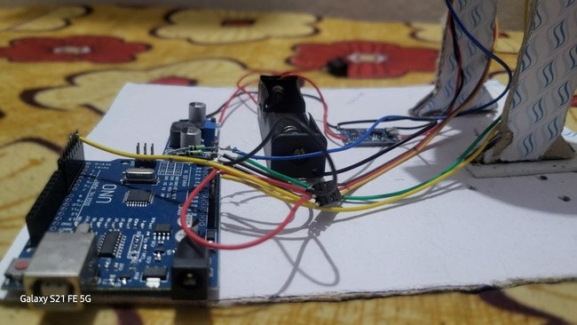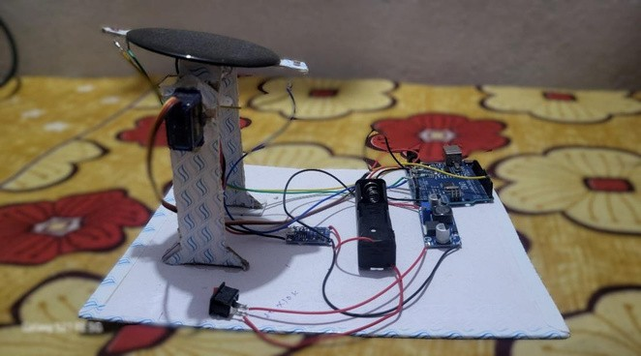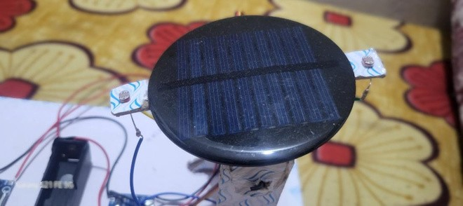
9
. SNAPSHOTS OF MODEL

